

Ashikur Rahman

*Lecturer*

Daffodil International Professional Training Institute (DIPTI)

Daffodil Technical Institute (DTI)

Permanent Campus: 43/R/5-B, Indira Road, Panthapath, Dhaka-1215

Kalabagan Campus: 64/6, Lake Circuss, Kalabagan, Russell Square, Dhaka-1205

Tel: 02-9134695, Phone: +8801670153938 (Personal)

E-mail: [ashik@dipti.com.bd](mailto:admin-dep@dipti.com.bd), web: [www.dipti.com.bd](http://www.dipti.com.bd/), [www.dti.ac](http://www.dti.ac/)

**Computer Memory**

Memory is the most essential element of a computing system because without it computer can’t perform simple tasks. Computer memory is of two basic type – Primary memory (RAM and ROM) and Secondary memory (hard drive, CD, etc.). Random Access Memory (RAM) is primary-volatile memory and Read Only Memory (ROM) is primary-non-volatile memory.

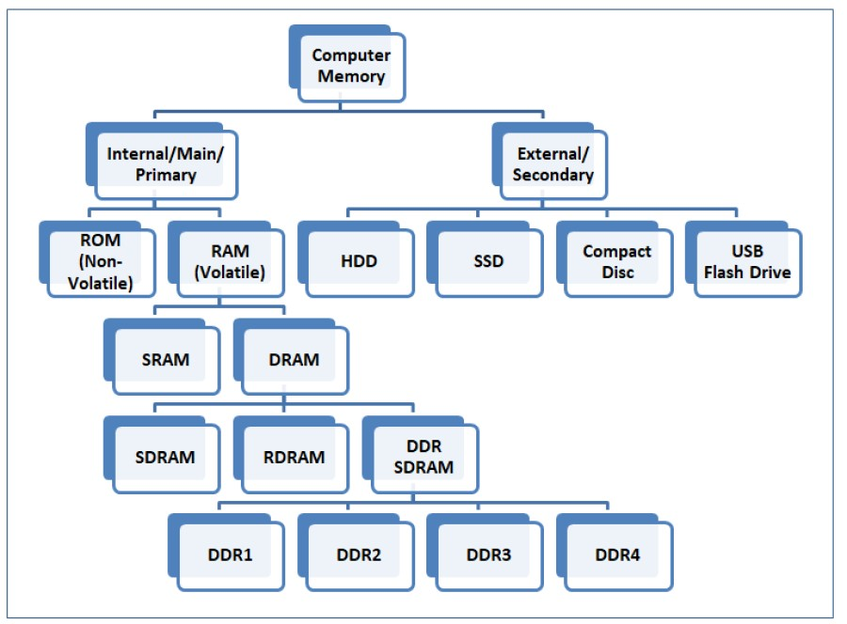

**Primary Memory**

Primary memory is computer memory that is accessed directly by the CPU. This includes several types of memory, such as the processor cache and system ROM. However, in most cases, primary memory refers to system RAM.

RAM, or random access memory, consists of one or more memory modules that temporarily store data while a computer is running. RAM is volatile memory, meaning it is erased when the power is turned off. Therefore, each time you start up your computer, the operating system must be loaded from secondary memory (such as a hard drive) into the primary memory, or RAM. Similarly, whenever you launch an application on your computer, it is loaded into RAM.

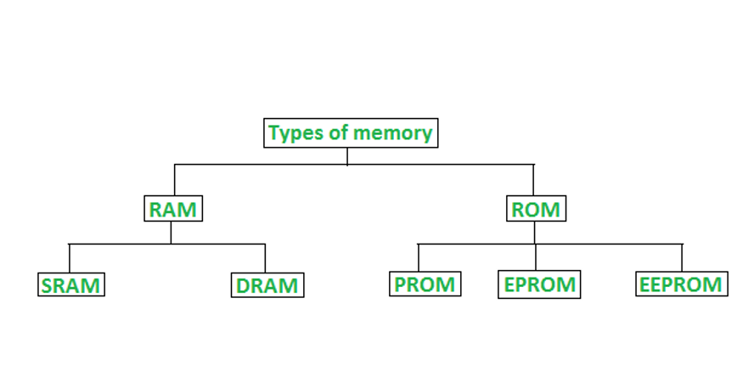The operating system and applications are loaded into primary memory, since RAM can be accessed much faster than storage devices. In fact, the data can be transferred between CPU and RAM more than a hundred times faster than between the CPU and the hard drive. By loading data into RAM, programs can run significantly faster and are much more responsive than if than constantly accessed data from secondary memory.

**RAM (Random Access Memory):**

RAM (Random Access Memory) is a part of computer’s Main Memory which is directly accessible by CPU. RAM is used to Read and Write data into it which is accessed by CPU randomly. RAM is volatile in nature, it means if the power goes off, the stored information is lost. RAM is used to store the data that is currently processed by the CPU. Most of the programs and data that are modifiable are stored in RAM.

* It is also called as read write memory or the main memory or the primary memory.
* The programs and data that the CPU requires during execution of a program are stored in this memory.
* It is a volatile memory as the data loses when the power is turned off.
* RAM is further classified into two types- SRAM (Static Random Access Memory) and DRAM (Dynamic Random Access Memory).

**SRAM (static random access memory):**

Static Random Access Memory (Static RAM or SRAM) is a type of RAM that holds data in a static form, that is, as long as the memory has power. Unlike dynamic RAM, it does not need to be refreshed. SRAM memories are used to build Cache Memory.

There are two basic kinds of semiconductor memory. Static RAM (SRAM) consists of flip-flops, a bistable circuit composed of four to six transistors. Once a flip-flop stores a bit, it keeps that value until the opposite value is stored in it. SRAM gives fast access to data.

**DRAM (dynamic random access memory):**

DRAM is widely used as a computer’s main memory. Each DRAM memory cell is made up of a transistor and a capacitor within an integrated circuit, and a data bit is stored in the capacitor. Since transistors always leak a small amount, the capacitors will slowly discharge, causing information stored in it to drain; hence, DRAM has to be refreshed (given a new electronic charge) every few milliseconds to retain data.

**Synchronous DRAM (SDRAM):** “synchronizes” the memory speed with CPU clock speed so that the memory controller knows the exact clock cycle when the requested data will be ready. This allows the CPU to perform more instructions at a given time. Typical SDRAM transfers data at speeds up to 133 MHz.

**Rambus DRAM (RDRAM):** takes its name after the company that made it, Rambus. It was popular in the early 2000s and was mainly used for video game devices and graphics cards, with transfer speeds up to 1 GHz.

**Double Data Rate SDRAM (DDR SDRAM):** DDR SDRAM is a type of synchronous memory that nearly doubles the bandwidth of a single data rate (SDR) SDRAM running at the same clock frequency by employing a method called "double pumping," which allows transfer of data on both the rising and falling edges of the clock signal without any increase in clock frequency.

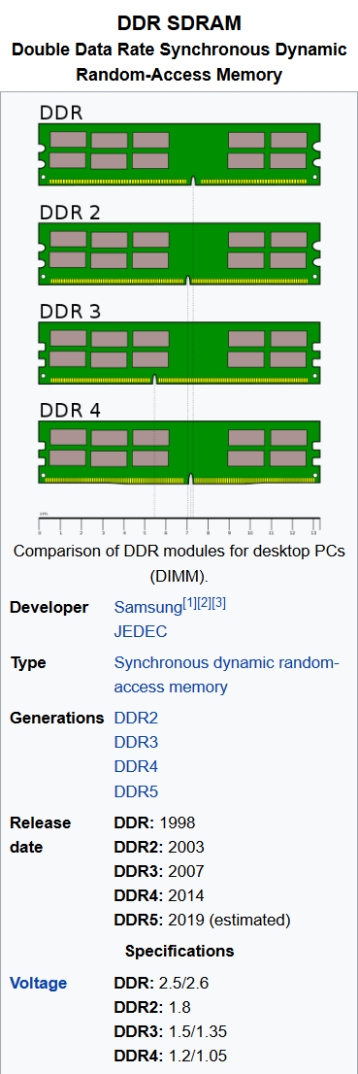

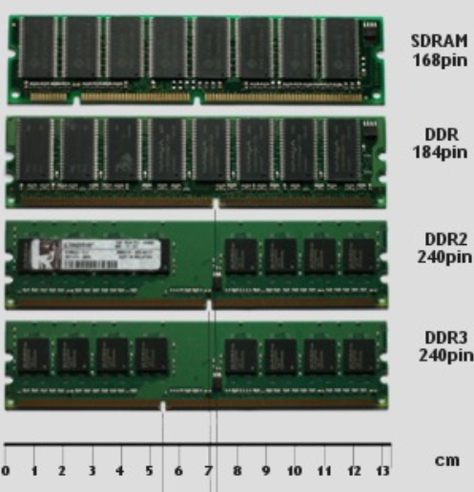

You will notice from the picture above that SDRAM memory modules have two notches in the contacts while DDR, DDR2, and DDR3 have just one notch which is located in a different place on each memory module. This is because all these types of RAM are incompatible with each other and it makes it impossible to put the wrong type memory module into a motherboard's memory slots because of these notches.

Laptop RAM has the same types of RAM but are incorporated onto a physically smaller sized memory module called a SO-DIMM (Small Outline Dual in-line Memory Module). They also have notches in the memory module so it is impossible to mix them up.

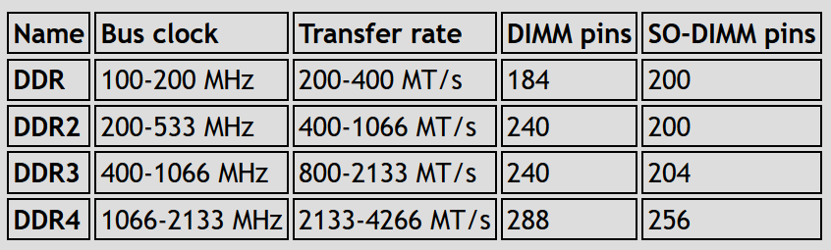

**DDR SDRAM (Double Data Rate SDRAM):**

The next generation of SDRAM is DDR, which achieves greater bandwidth than the preceding single data rate SDRAM by transferring data on the rising and falling edges of the clock signal (double pumped). Effectively, it doubles the transfer rate without increasing the frequency of the clock. The transfer rate of DDR SDRAM is the double of SDR SDRAM without changing the internal clock. DDR SDRAM, as the first generation of DDR memory, the prefetch buffer is 2bit, which is the double of SDR SDRAM. The transfer rate of DDR is between 266~400 MT/s. DDR266 and DDR400 are of this type.

**DDR2 SDRAM (Double Data Rate Two SDRAM):**

Its primary benefit is the ability to operate the external data bus twice as fast as DDR SDRAM. This is achieved by improved bus signal. The prefetch buffer of DDR2 is 4 bit (double of DDR SDRAM). DDR2 memory is at the same internal clock speed (133~200MHz) as DDR, but the transfer rate of DDR2 can reach 533~800 MT/s with the improved I/O bus signal. DDR2 533 and DDR2 800 memory types are on the market.

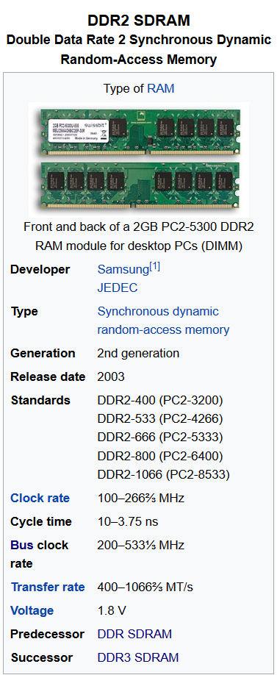

**DDR3 SDRAM (Double Data Rate Three SDRAM):**

DDR3 memory reduces 40% power consumption compared to current DDR2 modules, allowing for lower operating currents and voltages (1.5 V, compared to DDR2's 1.8 V or DDR's 2.5 V). The transfer rate of DDR3 is 800~1600 MT/s. DDR3's prefetch buffer width is 8 bit, whereas DDR2's is 4 bit, and DDR's is 2 bit. DDR3 also adds two functions, such as ASR (Automatic Self-Refresh) and SRT (Self-Refresh Temperature). They can make the memory control the refresh rate according to the temperature variation.

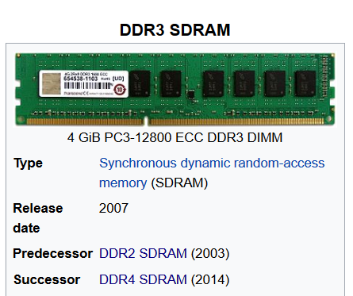

**DDR4 SDRAM (Double Data Rate Fourth SDRAM):**

DDR4 SDRAM provides the lower operating voltage (1.2V) and higher transfer rate. The transfer rate of DDR4 is 2133~3200 MT/s. DDR4 adds four new Bank Groups technology. Each bank group has the feature of singlehanded operation. DDR4 can process 4 data within a clock cycle, so DDR4's efficiency is better than DDR3 obviously.

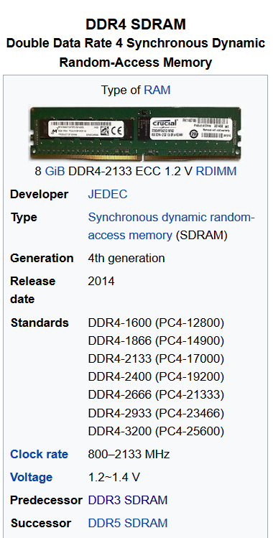

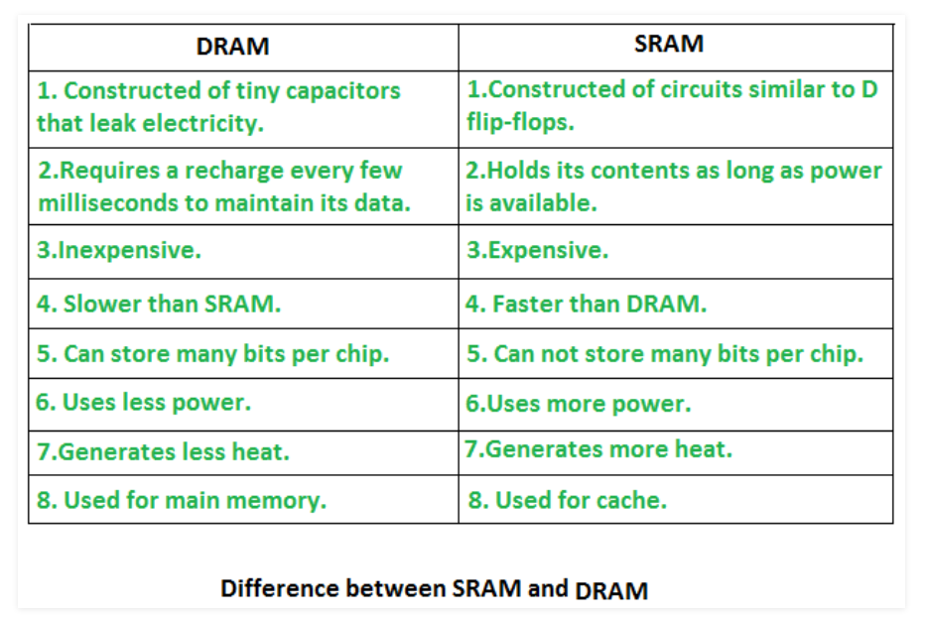

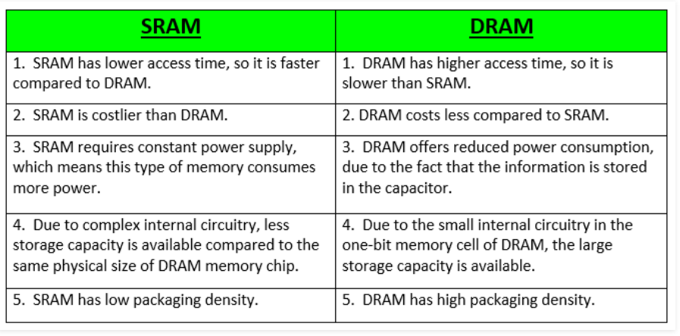

**Read Only Memory (ROM):**

* Stores crucial information essential to operate the system, like the program essential to boot the computer.
* It is not volatile.
* Always retains its data.
* Used in embedded systems or where the programming needs no change.
* Used in calculators and peripheral devices.
* ROM is further classified into 4 types- ROM, PROM, EPROM, and EEPROM.

**Types of Read Only Memory (ROM):**

1. PROM (Programmable read-only memory) – It can be programmed by user. Once programmed, the data and instructions in it cannot be changed.
2. EPROM (Erasable Programmable read only memory) – It can be reprogrammed. To erase data from it, expose it to ultra violet light. To reprogram it, erase all the previous data.
3. EEPROM (Electrically erasable programmable read only memory) – The data can be erased by applying electric field, no need of ultra violet light. We can erase only portions of the chip.

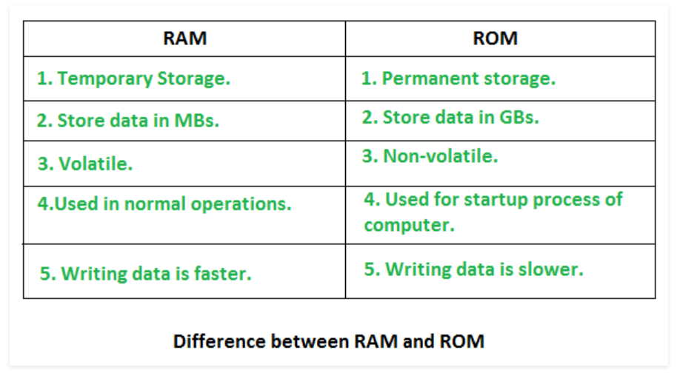

**Difference between Virtual memory and Cache memory**

**Cache Memory:**

Cache memory increases the accessing speed of CPU. It is not a technique but a memory unit a storage device. In cache memory, recently used data is copied. Whenever the program is ready to be executed, it is fetched from main memory and then copied to the cache memory. But, if its copy is already present in the cache memory then the program is directly executed.

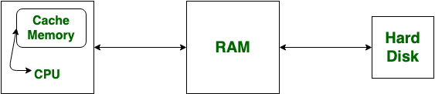

**Virtual Memory:** Virtual Memory increases the capacity of main memory. Virtual memory is not a storage unit, it’s a technique. In virtual memory, even such programs which have a larger size than the main memory is allowed to be executed.

